Amrita School of Engineering, Bengaluru
Course Registration Form (Ph.D. Scholars)

Name of the Scholar | : | Samrat Kar
Registration No. | : | BL.SC.R4CSE24007
Date of Registration | : | Aug 2024
Department in which registered | : | Computer Science
Name of the Thesis Advisor | : | Dr Nandu C Nair
Credits earned so far | : | zero

Details of the course(s) being registered during Odd. Sem. of Academic Year 2023-24

Sl.  No. | Course Code | Course Title | Course Credits | Offered by | Signature of the  faculty member offering the course
1 | 24RM801 | Research Methodology for Engineering |  | Dr. R. Pramod

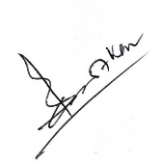
Signature of the Scholar Signature of the Thesis Advisor

Date : 19 Oct 2024 Date :

Chairman- PGP
To be submitted in triplicate:
Chairman-PGP Office Copy / Examination Cell Copy / Academic Coordinator’s Office Copy

